**A STUDY IN HOW TO IMPROVE ENGLISH SPEAKING SKILL THROUGH ACTIVITIES IN CLASS**

|  |  |
| --- | --- |
| **Author:** | **Nguyen Thi Nhung** |

**TABLE OF CONTENT**

|  |  |
| --- | --- |
| CONTENT | PAGE |
| **PART 1: INTRODUCTION** |  |
| 1. Rationale of the study |  |
| 2. Aims of the study |  |
| 3. Scope of the study |  |
| **PART 2: LITERATURE REVIEW** |  |
| 1. Definition of speaking2. Speech production in a foreign language2. Classroom speaking activities |  |
| **PART 3: IMPLICATIONS** |  |
| Suggestions for teaching speaking in class  1. Discussion (debate)  2. Role play  3. Role cards  4. Simulation  5. Talking cards  6. Story telling  7. Questionares |  |
| **PART 4: CONCLUSION** |  |
| REFERENCES |  |

**PART 1: Introduction**

**1. Rationale of the study**

|  |
| --- |
| English is now used by millions of speakers for a number of communicative functions across the world and Vietnam is not an exception. Recently, English has become a vital and mandatory communication language in Vietnam. Many English-speaking foreigners started coming to invest in Vietnam. This has encouraged the people of Vietnam to learn English to facilitate efficient and effective communication among their counterparts. The importance of English was immediately acknowledged by the Vietnamese government and as a result the English language programs were made compulsory beginning with the secondary schools and subsequently the high schools and finally university.  According to many Vietnamese schools’ curriculum, teaching a foreign language used to strongly focus on grammar, sentence structures and vocabulary. In such a teaching format, conversational English was not paid much attention. In addition, English learning and teaching is examination-based. Examinations were mainly grammar-focused. This has caused students to become less interested in this language because English is just another subject at school, not part of their life. Many students eventually fail to see the importance and pride in being able to speak fluent English.  In recent years, the teaching methodologies of English has been through an enormous amount of changes and improvements especially in the areas of how the communicative approach is being widely applied and integrated into the English learning language classrooms. In classrooms of today, we see more and more learner response taking place. As a result, the English curriculum has also been revamped to generate youths which are able to communicate holistically in English and not merely in grammar theories.  Among the other foreign language skills such as listening, reading and writing, speaking skill seems instinctively the most important one. As the process of learning and applying the skills of oral English are so closely related, classroom should be a place where the use of spoken language is sensitively supported since it enables students to make connections between what they know and what they are learning, and it is the one through which they are going to be judged while the first impressions are being formed.  In practice or in real classroom situation, those learners find it difficult to communicate or interact using the target language. They think that speaking a foreign language perfectly with a good pronunciation, fluency,… is a so complex task to fulfill.  **2. Aims of the study** |

This latter is the concern of this major. It aims at presenting a brief description for foreign language speaking skill and its recent status in the light of what was presented in the related literature particularly within the emergence of the recent communicative approach to FLT. It tends to clarify the factors that affect students' speaking abilities, with specific expression of the common dilemmas teachers face when trying to address the teaching of speaking.

It covers some issues or points needed to tackle when dealing with speaking, as it shows the necessary activities must be designed by the teacher in classroom in order to enable the learners to produce a meaningful English oral performance as well as to overcome their weakness and difficulties.

**3. Scope of the study**

Within the scope of the study, emphasis is laid on the teaching and learning speaking session performed by students under teachers’ instructions. The study also focuses on speaking for specific projects such as role plays, debate, role cards, simulations etc. The population of the study is limited to students at Lao Cai high school for gifted students in the academic year of 2017-2018

|  |
| --- |
| **PART 2: LITERATURE REVIEW** |

In this chapter, the authors present the theoretical background relevant to the research

1. **Definition of speaking**

Speaking is the delivery of language through the mouth. To speak, we create sounds using many parts of our body, including the lungs, vocal tract, vocal chords, tongue, teeth and lips. This vocalized form of language usually requires at least one listener. When two or more people speak or talk to each other, the conversation is called a "dialogue". Speech can flow naturally from one person to another in the form of dialogue. It can also be planned and rehearsed, as in the delivery of a speech or presentation. Speaking can be formal or informal:

* Informal speaking is typically used with family and friends, or people you know well.
* Formal speaking occurs in business or academic situations, or when meeting people for the first time.

Speaking is probably the language skill that most language learners wish to perfect as soon as possible. It used to be the only language skill that was difficult to practice online. This is no longer the case. English learners can practice speaking online using voice or video chat and services like Skype. They can also record and upload their voice for other people to listen to.

# 2. Speech production in a foreign language

Similar to listening, speaking is a skill which deserves much attention every bit as much as other language skills are concerned, in both first and second languages since in EFL classrooms, teaching speaking plays a great role for the learner's good oral achievement (Bygate, 1987). He quoted that:

## "Speaking is the vehicle par excellence of social solidarity, of social ranking, of professional advancement and of business .It is also the medium through which much language is learnt, and which for many is particularly conductive for learning. Perhaps, then, the teaching of speaking merits more thought" (P, 1)

So, besides this big importance, it is necessary to deal first with what good speakers of a foreign language can do. Hence it was assumed that the ability to speak fluently is all the time associated with certain characteristics to be owned by the speaker. This latter is presented in the teaching of grammar, an amount of vocabulary with some care about pronunciation so that the piece of the produced speech sounds as the native speakers' ones. But, now we all know that this skill is more complex than that; it involves the cooperation of different types of knowledge with the good command of certain skills. (Bygate, 1987).

A good starting dealing to tackle this skill is to ask ourselves; how we achieve this ability? and how to do it all over again in a foreign language such as English.

Different factors are involved in speaking. The first one to emphasize is that this human ability is an interactive process, its form and meaning depend on the participants, their previous experiences, the physical setting and the purpose of speech (Brown, 1994).

Generally speaking , this process takes place in real time and is described to be linear ; so this process follows a certain permanent series of stages ( words follow words and phrases follow phrases) (Thornbury, 1998). At the level of utterances, or the spoken presentation of sentences, this produced speech goes utterance by utterance opposite to word by word with the same rhythm from the part of the interlocutor.

In its production, speech nature is described to be contingent through which we find that each word is dependent on the previous one and the same thing for utterances (interrelationship between utterances) and this fact leads to what is called in speaking "spontaneity" and this concept doesn't mean that speech is unplanned but as (Thornbury, 1998) clarifies, the planning time is limited . He adds that :

* **the planning of one utterance may overlap with the production of the previous one ",** according to him all the previous explained characteristics are closely related to **"real time processing" which is well determined by (Bygate, 1984) to be :**
* **We have to produce sentences and adopt them to the circumstances . This means making decisions rapidly, implementing them smoothly as unexpected problems appear in our path".**

# 3. Classroom speaking activities

English teaching methods are different from other subjects teaching method in which require a degree of real time exposure in order for learners to be clearly understood when speaking, and the ability to use effective oral communication skills are so important particularly that given speech remains the form of communication most often used. To deal with speaking a foreign language, this latter can be realized through a set of classroom activities which have to be developed best in a dynamic interactive learning environment where both teacher and learners collaborate and cooperate with one another to create a safe, comfortable and relaxed atmosphere for a perfect productive talk in classroom.

For that aim , FL teachers try to develop their learners communicative competence through the diversity of activities in their classes which must include the different types and styles of expressions , the different accents and dialects of native speakers and acquainting students with the different language discourses and situational as well as contextual expressions( business English , post office , jargon…ect). Each teacher is going to select and adapt the suitable activity and strategy that meets his learners needs , interests and goals . According to (Harmer, 2001), in the Oral expression course; the most widely used speaking activities should: “fall at or near the communicative end of the communication continuum".

Through the following classroom speaking activities , the teacher tries all the time to create interaction by exchanging information and expressing ideas of course with an exclusive care about the correct grammar (accuracy), adequate vocabulary, acceptable fluency as well as a good pronunciation to convey a meaning through speech which sounds like a native speakers ' one.

# PART 3: IMPLICATIONS

# Discussion (debate):

# According to Oxford dictionary, debate is a formal discussion on a particular matter in a public meeting or legislative assembly, in which opposing arguments are put forward and which usually ends with a vote.

Discussion is considered as one among the best ways of presenting speech and it is an interesting form of oral practice in the classroom.

## "it can provide some of enjoyable and productive speaking in language classroom" (Harmer, 1995, 46) According to ( Thornbury, 1998 ), "many teachers would agree that the best discussions in class are those that arise spontaneously either because of something personal that a learner reports or because a topic or a text in the course book triggers some debate" ( p,102).

Discussion differs from conversation in the fact that it generally has an identifiable purpose. Then, it is similar to conversation in the sense that both involve listening carefully, considering what others say and speaking. Many of students’ conversational abilities will transfer into discussion situations.

Discussion in foreign language classrooms generally help FL learners to develop their communicative abilities since it gives them practice in expressing ideas orally in an organized manner and enables them to arrive at conclusions, to clarify or modify ideas, resolve differences and find alternative solution because through discussion, learners can bring their personal experiences and outside world into the classroom, where they tackle different topics and subjects which concern every individual. (Littlewood, 1999) explains that through class discussions the

learners are able to use the foreign language as a medium to talk about their experiences and express their views , opinions and handling their social relationships.

Besides this great importance, FL teachers generally claim about what is named "discussion failure "(Harmer, 2001, 272). The reason of this later as he explains is that FL learners are reluctant to give their opinions in front of the whole class because of a noticed lack of self-confidence (shyness and fear of making mistakes, lack of adequate vocabulary and accurate grammar…)

## "Many students feel extremely exposed in discussion situation" (Harmer,2001,272)

In this stream, (Harmer, 2001) suggests a technique to realize a successful oral discussion and to avoid all the speaking difficulties which might encounter the learners , this will be through " Buzz group" which is based upon the formation of small groups , it gives the learner the chance to talk and interact at the same time.

Through this" Buzz group" ' application, before being asked to perform orally in front of the whole class, the level of learners stress will be reduced. (Harmer, 2001) has illustrates some examples to show the usefulness of the cited technique for a whole range of discussions, for example:

1/ Let students to predict the content of a reading text or invite them to talk about their reactions to it after reading.

2/ Discuss what should be included in a news broadcast or have a quick conversation about Types of music for example.

3/ The topic may be fashion and the statements to discuss might include the following:

* Fashion is universal.
* Fashion is an art form.
* People shouldn't be judged by what they wear.
* Fashion is just a way of making people spend money.
* Fashion celebrates diversity, …

Of course all these statements should be reinforced with a view of eliciting a more personal response phrased as questions during the discussion such as;

How important is the label on an item of clothing?

How often do you shop for clothes?

How would you describe your style of dressing?

4/ To train learners to respond directly and spontaneously through ' instant comments ' through showing them pictures or introducing any topic at any stage of the lesson then ask them to make their first impressions .

5/ Another example for EFL classroom oral discussion involves 'formal debate' where students are asked to prepare arguments in favor or against various prepositions (Harmer, 2001), e.g.

An invigilator during an official exam catches a student sheeting from a hidden notes .The class should discuss the topic of sheeting in exams in general and decide about the following statements :

The invigilator should ignore him.

She should give the student a sign to show that she has seen him, so that the student will stop.

She should inform the exam board so that the student will not be able to pass that exam again.

As a result, the important factor to consider when dealing with oral discussions in FL classrooms is students’ engagement with the topic and their interest, provide them with period for thinking, arrangement of ideas and language expressions they will use.

# Role plays

# Role play is the act of imitating the [character](https://www.collinsdictionary.com/dictionary/english/character) and [behavior](https://www.collinsdictionary.com/dictionary/english/behaviour) of someone who is different from yourself, for example as a training exercise.

It is among the very common classroom speaking activities, according to (Ur, 1984), it is one way to consider when a teacher wants to vary the kinds of the spoken interaction experienced in classroom**.** Role plays provide the opportunity for students and revise their understanding and perspective by exploring thoughts and feelings of characters in a given situations.

This special speaking activity is said to have many positive impacts on learners in classroom

* + It gives them empathy as they examine others' ideas, feeling and points of views.
  + It is a chance to practice their oral skills and interpretations as they use the foreign language to describe perceptions, emotions and reactions.
  + It provides them with the opportunity to practice decision –making and problem-solving skills as they gain experience in an independent thinking and cooperative learning.
  + It develops both speaking and listening activities.

In role plays students have to imagine a role (e.g. a candidate) and a situation (e.g. a job interview). A role play in EFL classroom is a drama like activity, it can take many forms.

### For example: Bizarre Job Interviews

* **Cover background knowledge about strange jobs.** Ask your students as a class about a few jobs they may have had, or possibly some bizarre jobs they may have heard about. This promotes imagination, creativity and will serve as a great warm-up activity. You can even share a bizarre job of your own, or of a friend. Maybe you or someone you know spent a summer as a kiwi picker in New Zealand, or cleaned cages at the zoo.
* **Give out the roles.** You will need to have made a few worksheets for each job interviewer ahead of time. A fun twist is to let the interviewer know which job the interviewee will be interviewing for, but to keep the interviewee in the dark until the activity begins. For example, let’s say Student A has a list of questions to ask Student B, the interviewee. Student A might read, “How did you hear about the position for tiger tooth cleaner?” Student B will need to spontaneously come up with an answer. It is fun!
* **Have students write answers.** You can also have Student A write down Student B’s answers. The last question should give Student B an opportunity to ask the interviewer any questions he or she may have about the job. For example, “How many tigers are there?” This will evoke quick, spontaneous response from Student A.
* **Take turns.** Your students should switch roles among the different interview tables and bizarre jobs. As the exercise continues, you could even be an interviewer or interviewee to add to the excitement and fun of the role play activity.

Communication, asking and answering questions, improvisation, writing, reading and confidence building are the vital ESL skills involved in this activity.

1. **Role cards**

This strategy promotes active discussion by using role cards and uses colors to differentiate for different skill levels. The example below assumes that you are using blue for the less able and green for the more able students. "Participant are given a situation plus problem or task, as in simulation, but they are allotted individual roles, which may be written out on cards"

So, role cards as a role play technique gives the opportunity for learners 'performances to be guided through instructions presented in cards for enabling them to act out what may occur**.**

How to Use the Strategy:

1. Make one poster-sized copy of the Pointer/Signal Words Chart (located to your right) and post it in the classroom for student reference.
2. Copy, laminate, and cut the Blue Role Cards for Expository Text and the Green Role Cards for Expository Text (both are located to the right). Make enough copies so that each student will receive a card that is appropriate for his/her readiness level.
3. Divide the students into homogeneous readiness-level groups of four and give each student in each group one of the individual cards. (Make sure each group has cards for all four roles).
4. Tell students to read their cards to find out what their individual role will be for the group discussion.
5. Students read the chapter or section of the book.
6. Provide time for group discussion.  Each group member should participate based on the role on his/her card.
7. Give each group a large sheet of paper and some markers.
8. Ask each group to figure out a way to show the key elements of its discussion by making a graphic representation on the large sheet of paper.
9. Have each group present its graphic representation to the rest of the class.
10. Display the posters.

For examples:

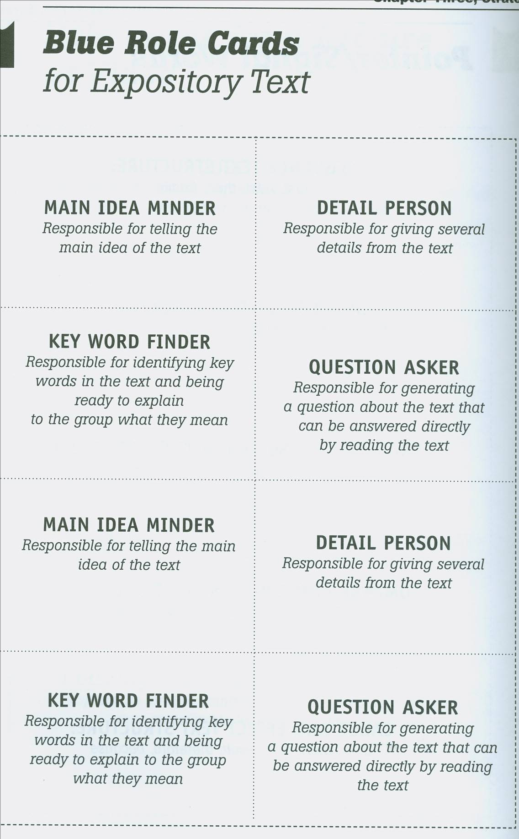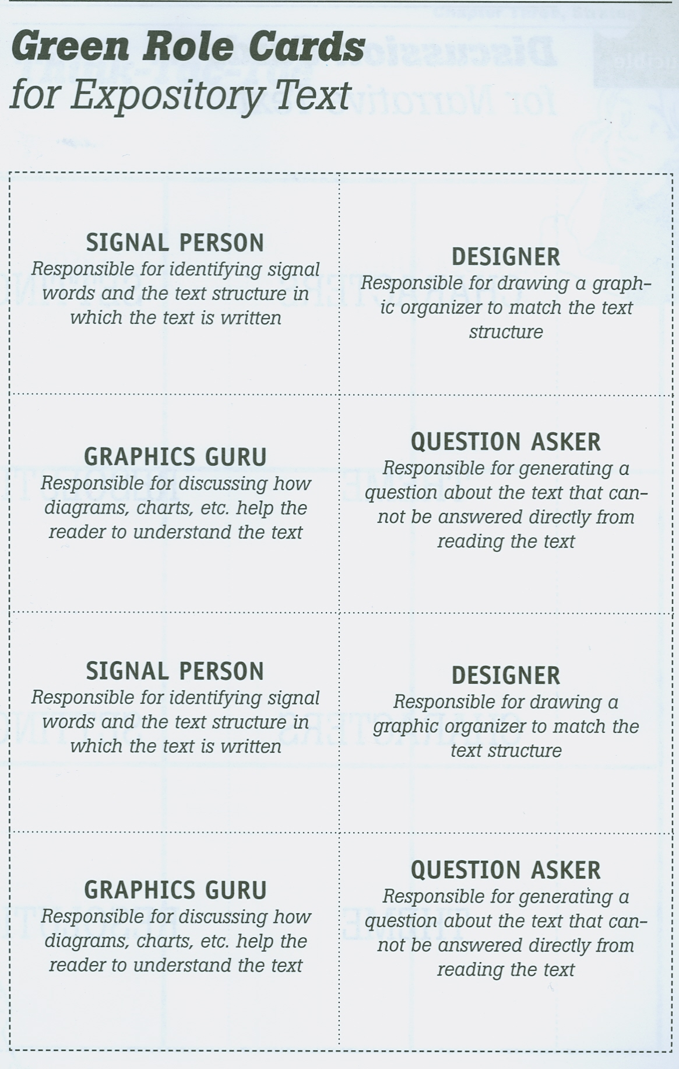

**4. Simulation**

It is another role play activity which can be to develop oral fluency, "where student simulate a real life encounter […] as if they were doing so in the real world as themselves" (Harmer, 2000, 274).

It is similarly defined by (Ur,19984):

## "In simulation the individual participants speak and react as themselves, but the group role, situation and task they are given is an imaginary one" (132).

For a simulation to work it must according to (Kenjohns reported in Harmer, 2000) have the following characteristics:

* "Reality of function"; where students feel their complete involvement in the situation as if it really exists and they act as a real participant.
* "A simulated environment " created by the teacher
* "Structure " in which students must have a general view about the tasks to be performed and the activity to be done

Furthermore, it seems somehow difficult to distinguish between the two sorts of activities (role play and simulation as a type of a role play) , but the clear difference lies in the fact that simulation is more difficult than role play since it requires learners not to act as characters that are not their own but get more personally involved ( using their own background and knowledge to the situation).

In simulation students generally work with small groups to feel confident, cooperative, sharing ideas and create motivation.

## Example:

You are the managing committee of a special school for blind children. You want to organize a summer camp for them, but your school budget is insufficient .Decide how you might raise the money

**4. Formation gap activities**

Another type among the classroom spoken interaction activities is what is described by (Harmer, 2002) to be:

## "Where two speakers have different parts of information making up a whole, because they have different information, there is a gap between them"(p,88)

In foreign language classrooms, gap activities are proved to be among the most useful in second language acquisition since **"it provides negotiation of meaning and the conversational adjustment which push students to more accurate output" (Hedge, 2, 281).**

This activity has a requirement for information exchange

## "It involves each learner in a pair or a group possessing information which the other learners do not have"(Hedge, 2000, 281).

## Here are some tips for this activity

## Do:

* Listen carefully to the instructions.
* Ask your teacher to repeat if you don’t understand exactly what you have to do.
* Look at your partner and check that he/she understands you when you speak.
* Be ready to repeat or explain things if he/she doesn’t understand you.
* Listen to your partner’s answers carefully and show interest in what your partner says.
* Take turns with your partner.

## Don’t:

* Talk a lot more than your partner.
* Ignore what your partner says.
* Worry if you and your partner have different levels of English.
* Look at your partner’s worksheet and copy the answers

In practice, this information has to be shared through right questions. It exists many variants of information gap activities, for example ;"describe and draw" activity, in which one learner has a picture which mustn't be shown to the other learners , what the rest of the class has to do is to draw the same picture without looking at the original one. Of course the role of the first student is to give instructions and descriptions to act as a guide for his partners who have to ask questions (Harmer, 2002).

For example:

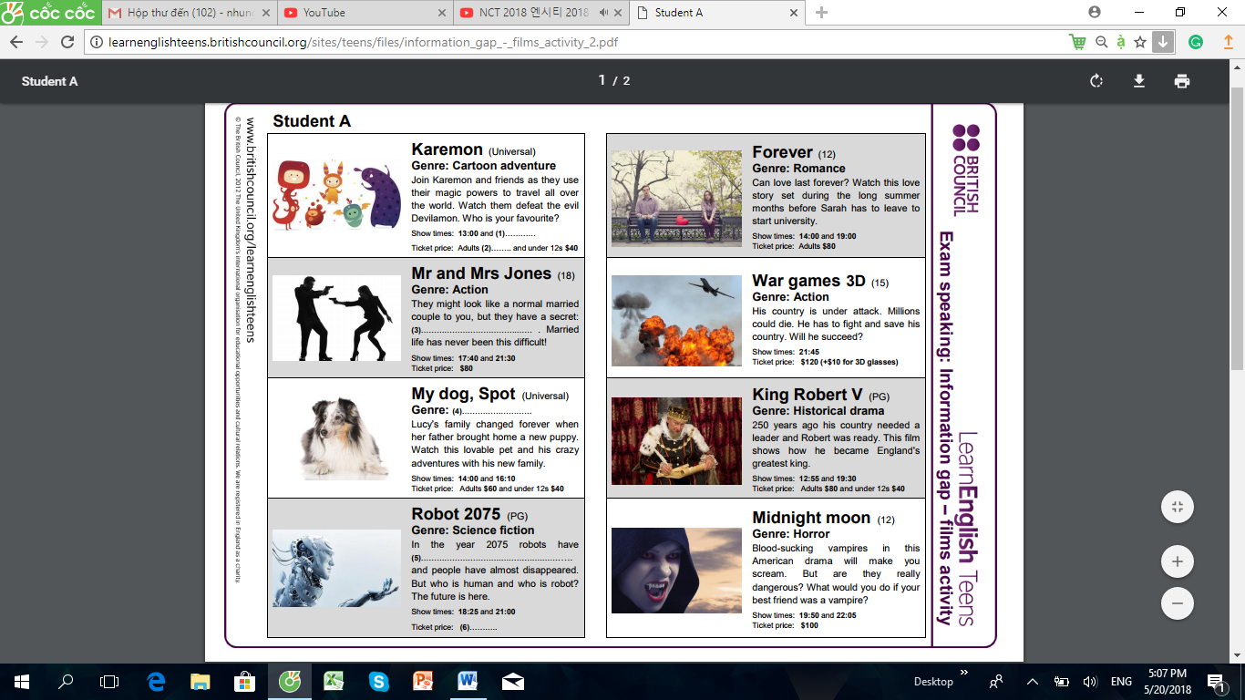

A further extension of the information gap activities in suggested in stories where for example the teacher provides his learners with an unfinished story and it depends on the rest of the class to guess and discuss the way it ends.

These information gap activities are seen by (Hedge, 2000) **to" have their own advantages and limitations, they assist language acquisition, but they do not involve students in conversational strategies in the same way as role plays or discussion" ( P 281)**

# 5. Talking circles

Talking circles provide safe environment where students are given the opportunity to share their points of view with their partners using the target language, of course without fear of criticism or judgment. This activity is useful when the discussed topic has no right or wrong answer, when students are sharing, feeling, considering moral or ethical issues as well. It is an effective strategy for reaching group consensus and for real life problem solving.

In class, the students sit in a circle and each one has the opportunity to speak.

During this spoken activity, both parts of interaction have some guidelines to follow:

* Only one student speak at a time, while the others listen and remain non judgmental.
* Address all comments to the issue or topic, not to comments made by other students (avoid both positive and negative responses to another student's comments).
* Encourage listeners to focus on the speaker supporting him by taking an interest in what he/she says, rather than turning and thinking about what they will say when it is their turn.
* Encourage speakers to share their comments in a way that is easiest and most comfortable for them (e.g. personal story, examples or metaphors, analytical statements).

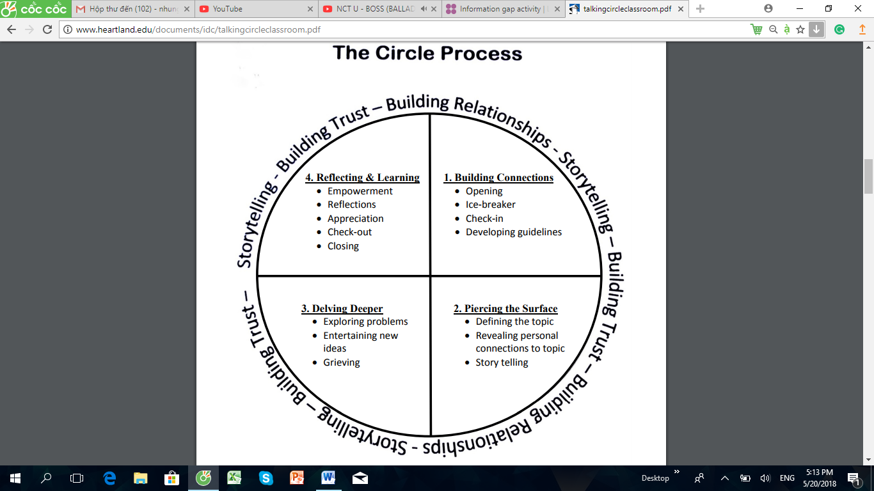

**6. Storytelling based activities**

This type of activities has always been one of the main means of practicing speaking in classroom. It functions as a clear tool towards autonomy and takes many forms;

Before your students engage in a storytelling project, devote class time to discussing key story components. By the end of the discussion, your students should have a firm grasp of the difference between a compelling *story*, and a mere *report*.

Warm-Up

* Ask your students to share the titles of their favorite story – one remembered from childhood, or a recent book or movie they’ve enjoyed.
* From their list, select 4-6 popular choices that represent a variety of genres; for example, a fairytale, action story, love story, historical fiction, etc.
* Next, facilitate a discussion about the elements that made these favorites. What was interesting about each? What made it memorable?

The Elements of a **Story**

* During your discussion, your students will naturally uncover elements that are common to stories in general. List them on the board as they’re identified, and examine the ways in which the authors successfully developed these elements in the Favorite Stories.

Your discussion should cover:

* **Theme** – Some stories have a **theme** – a central topic, concept or belief, and some have a **moral** – a lesson learned. Were these elements present in the Favorite Stories?
* **Character** – Most stories are about individuals – usually humans. A good storyteller enables their readers/listeners to clearly visualize each character, by eloquently describing both physical and personal attributes. The actions characters take should “ring true” to the reader, based on the individual traits that character exhibits early in the story.
* Most stories focus on one or two main characters. Generally the central character is sympathetic and relatable, so the reader feels empathy for that person and is thus drawn more deeply into the events unfolding. The “good guy” is known as the protagonist and the “bad guy” is the antagonist. The best characters feel “real” to the readers, because they have both positive and negative traits.
* Usually the most memorable stories result in some kind of meaningful **transformation** in the life of the main character.
* **Setting** – Every story is set in a location that’s integral to the narrative. Again, the reader should be able to visualize the setting from the author’s description. Unusual settings, such as those that are particularly beautiful, scary, exotic, or even alien may have a draw of their own, but familiar, everyday settings are also effective, enabling the reader to easily visualize and connect with the story.
* **Plot** – “Plot” is almost synonymous with “story” – it’s the flow of the story’s events, influenced, and to some degree *directed* by the characters’ reactions and decisions. Plots usually have three main elements: conflict, climax and resolution. Throughout the majority of the story, the characters are attempting to manage the conflict, which builds to the **climax** – the point of highest tension in the story, when the scales tip in one direction or another.
* **Conflict** – The plot element known as “conflict” is crucial to the success of the story. As [Writers’ Digest](http://www.writersdigest.com/online-editor/the-5-essential-story-ingredients) author Brian Klems said, “You do not have a story until something goes wrong.” Good stories include crisis, tension, struggle and discovery. “Page turners” are stories that create more and more tension as the story unfolds, intensifying the reader’s desire to discover the resolution.
* A story without a **resolution** would be unsatisfying, leading readers to demand, “So what *happens*??” The story’s action and tension must be resolved, for better or worse. The resolution should make sense, based on the events that took place, as well as what we have learned about the characters. However, interesting plots often include a “**twist**” – an unforeseen turn-of-events that the reader wasn’t expecting, therefore resulting in an unpredictable resolution. Overly simplistic plots may lead your readers to comment, “Heck, we all *knew* that was going to happen.”

Here are some activities for students in story telling session.

## Guess the lie:

In this activity learners tell each other three short personal anecdotes, where two among them are true and the third one is untrue and it depends on the others to guess the lie and to find the untrue anecdote so they argue their guesses. They can be allowed to ask a limited number of questions after the story has been told by their colleague (Thornbury, 1998, 96).

## Example:

Think about a lucky or unlucky experience you have had .You are going to tell your partners about it, choose from the list below the things you want to talk about .think about what you will say and what language you will need.

* Was it a lucky or unlucky experience?
* When did it happen?
* Where were you?
* Who were you with?
* What happened?
* Why was it lucky or unlucky?
* How did you feel afterwards**?**

## Insert the word:

Each student is given a card in which an unusual word or expression is written and has to be kept secret. The student has to tell his classmate an anecdote in which he / she incorporates 'the secret item ' as unobtrusively as possible, by the end, the students have to guess the secret words.

## Still in the same concern of storytelling based activities, student are allowed to tell jokes since the repeated practice of jokes in EFL classroom "Fulfils an important function of good speaking tasks" (Thornbury, 1998, 96).

**7. Questionnaires**

Questionnaires are useful as a communicative tool in classroom. They serve as **"a way of provoking conversation and opinion exchange "(Harmer, 2000, 89).**

This activity by being pre-planned by the students themselves becomes more useful, as (Harmer, 2000) had argued;

## "Questionnaires are useful because, by being pre-planned, they ensure that both questioner and respondent have something to say to each other" (p, 274).

The questionnaire as a spoken activity is considered to encourage the natural use of some repetitive language patterns (Harmer, 2000). Generally speaking, the questionnaire 'results can be taken as a basis for different oral tasks like: prepared talks, discussion and even written works (Harmer, 2000).

## Example

**TV Watching Questionnaire**

* **Do you like watching TV?**
  + **Yes**
  + **No**
* **If 'No', why?**

**…………………………………………………………………**

* **If ' Yes', How many hours do you normally watch TV**

**……………………………………………………………….**

* **What do you prefer to watch?**
  + **films**
  + **movies**
  + **talking shows**
  + **news**
  + **others**
* **Explain why**

**……………………………………………………………………..**

In classroom, with practicing questionnaires, students are allowed to go around the class and talk to their classmates and this latter allows them to have

## "a bit of physical movement and provide a welcome variety of interaction" (Thornbury , 1998 , 90).

|  |
| --- |
| **PART 4: CONCLUSION** |

Throughout this study, we have tried to consult or examine some of the theoretical aspects that concern foreign language speaking skill. We have demonstrated the role the oral communication generally and of speaking specifically in the process of learning and find that speaking is appropriate for learning objectives. In this chapter , we have shown what is meant by a successful oral performance stating that it is the ability and right to speak freely and clearly, unashamed, to fully vocalize, to choose to make contact with a word and to communicate that word successfully . Besides, this oral performance is so complex to realize and the speaking skill is extremely difficult to practice where foreign language learners encounter many constraints.

Yet, our FL teachers try to overcome these difficulties adopting a variety of tasks and techniques that feat the learners' interest, needs and level in order to develop discussion skills, interpersonal skills, critical listening, group interaction and problem solving … All in all we came up to the following points:

* To participate actively in class, students must be able to communicate clearly, effectively and appropriately in a variety of moods and contexts.
* Speaking is the oral articulation of ideas; it influences the development of critical thinking, problem solving abilities and general learning outcomes. It is an intellectual, social function .It shapes students perceptions of the world and represents these perceptions as knowledge and encourage FL learners to transform it as they shift through observations, evaluate information and compare views.
* Students become more proficient speakers as they adopt their capacities to use the language and the ideas appropriate to the situation, respond to listeners verbal and non verbal cues , restate ideas , ask questions to clarify understanding , use the language to create images and to produce emotional responses.
* For realizing the learners' active engagement in the speaking process, teachers need to determine the areas of difficulties their learners meet. So, they should structure, plan meaningful tasks and experiences within the classroom environment and present them in a more realistic and authentic manner.

Teachers have to encourage students to use the foreign language outside the classroom and try to provide them with suitable opportunities to do so.

REFERENCES

<https://www.ucm.es/data/cont/docs/119-2015-03-17-12.RocioSeguraAlonso2013.pdf>

<https://www.teachingenglish.org.uk/article/teaching-speaking-skills-2-overcoming-classroom-problems>

<https://www.slideshare.net/nourinarshad/class-activities-for-developing-speaking-skills>

<https://www.pinterest.com/pin/662732901385686024/?lp=true>

<https://www.fluentu.com/blog/educator-english/esl-listening-activities-intermediate/>

<https://www.teachingenglish.org.uk/article/role-play>

<http://www.rcsthinkfromthemiddle.com/role-cards.html>

<http://learnenglishteens.britishcouncil.org/exams/speaking-exams/information-gap-activity>

<http://learnenglishteens.britishcouncil.org/exams/speaking-exams/information-gap-activity>

<http://www.heartland.edu/documents/idc/talkingcircleclassroom.pdf>

<https://www.envisionexperience.com/blog/the-art-of-storytelling-with-free-classroom-activity-ideas>